xSetting up Jupyter Notebooks in AWS EMR

When creating the cluster, select JupyterHub 1.4.1 to be installed along with Spark

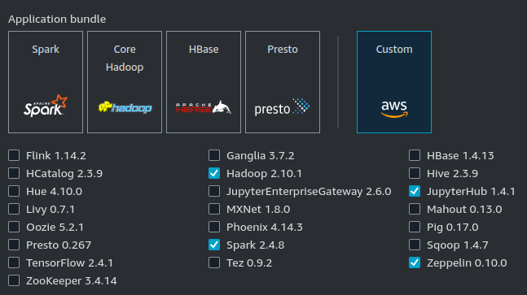

As your cluster is starting, go into the Network and Security section and click on “EC2 security groups (firewall)”. Then click on the link for the primary node:
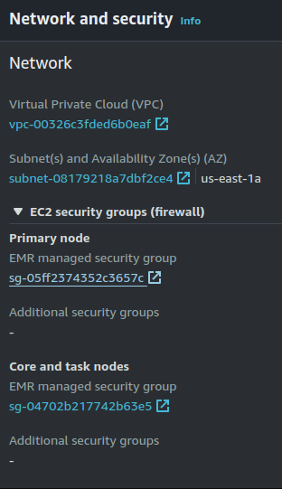
On the next page, click on “Edit inbound rules”:

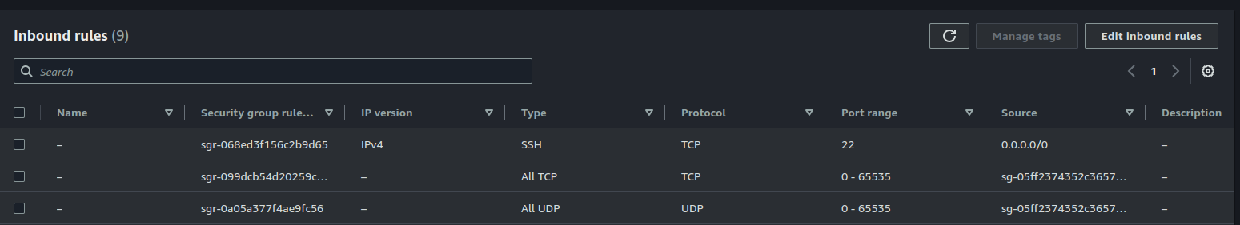

Scroll down and click “Add rule”. Then enter 9443 in the “Port range” column and select 0.0.0.0/0 in the “Source” column.

Then click on “Save rules”.

After that, click on “Services” in the top left corner of the screen and then select EMR. Then, click on “Block public access”

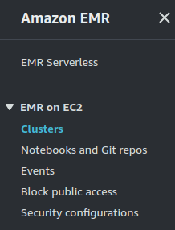

Once there, click “Edit” -> “Add port range”, enter 9443 and click Save.

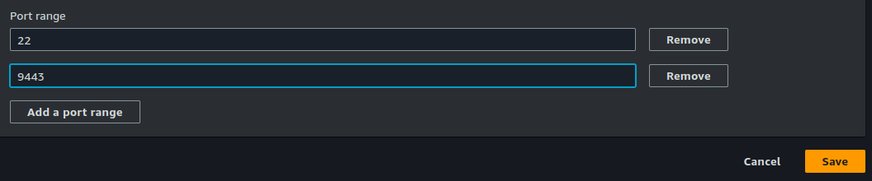
Next, in your Cluster management page, go to the “Applications” tab and look for the JupyterHub row.

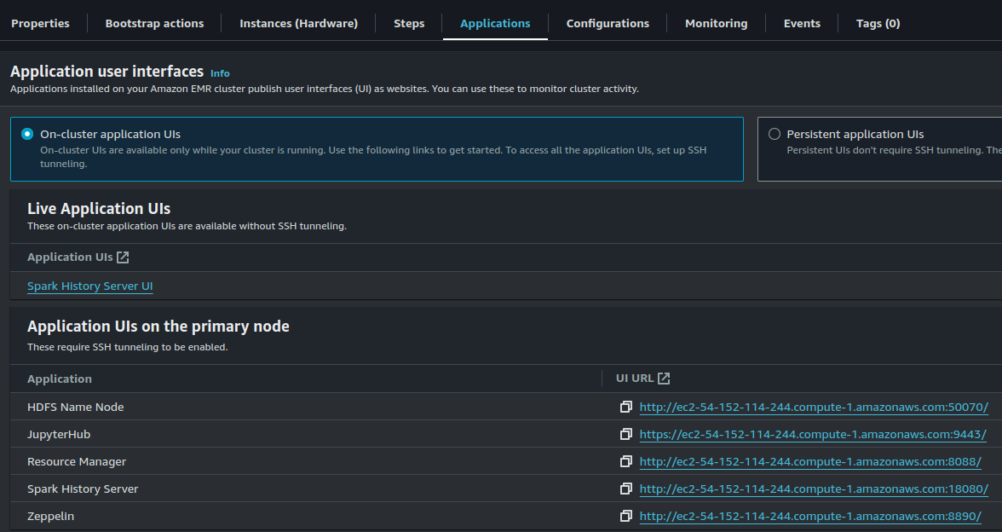

Note: These links won’t be available until your cluster is in the “Waiting” status.

Copy the link for JupyterHub and paste it in your browser. You will get the following message:

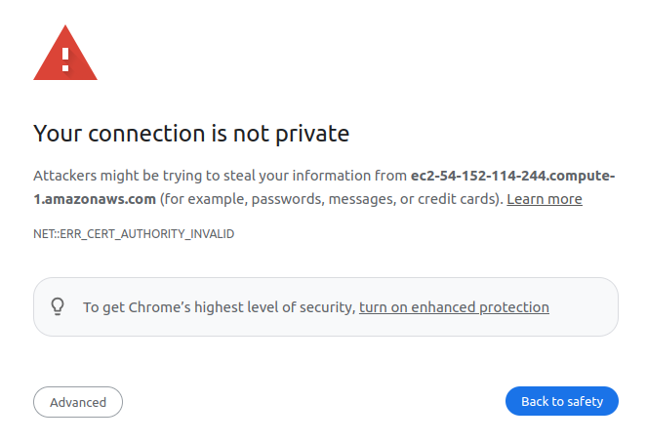
Simply, select Advanced and then proceed.
You will land at the following login page
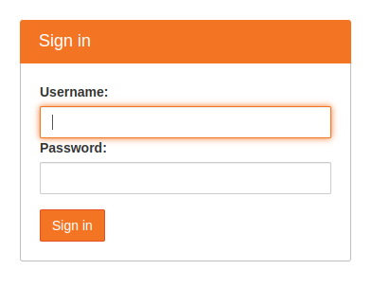
The default credentials are:

Username: jovyan
Password: jupyter

You should then be able to login and create a new notebook using Pyspark

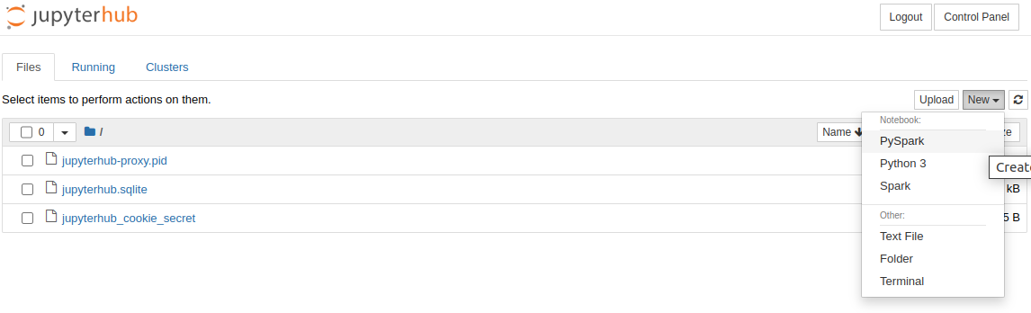
You only have to follow these steps once. After that, once you clone your cluster it will already be configured appropriately.

You must only wait until it reaches the “Waiting” status to obtain the JupyterHub link.

The notebooks you create will be saved in the following directory in your AWS instance:

/mnt/var/lib/jupyter/home/jovyan/

Hope this helps!

